Practical 6

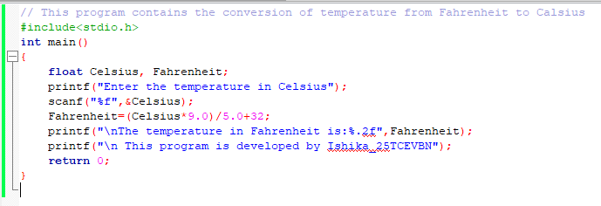

1. Given temperature is 0 degrees Celsius

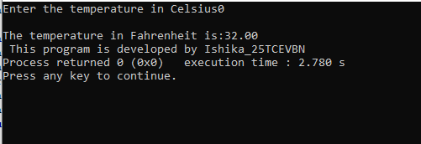

1. Given temperature is 100 degrees Celsius

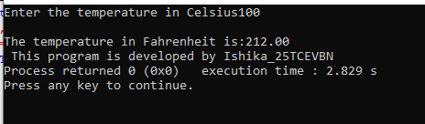

1. Given temperature is -40 degrees Celsius

